Qus 1 week 2nd
public class student {
// Private member variables
private String studentName;
private String collegeName;
private int studentID;

// Main method
public static void main(String[] args) {
System.out.println("Successful");
}
}
successful
Output
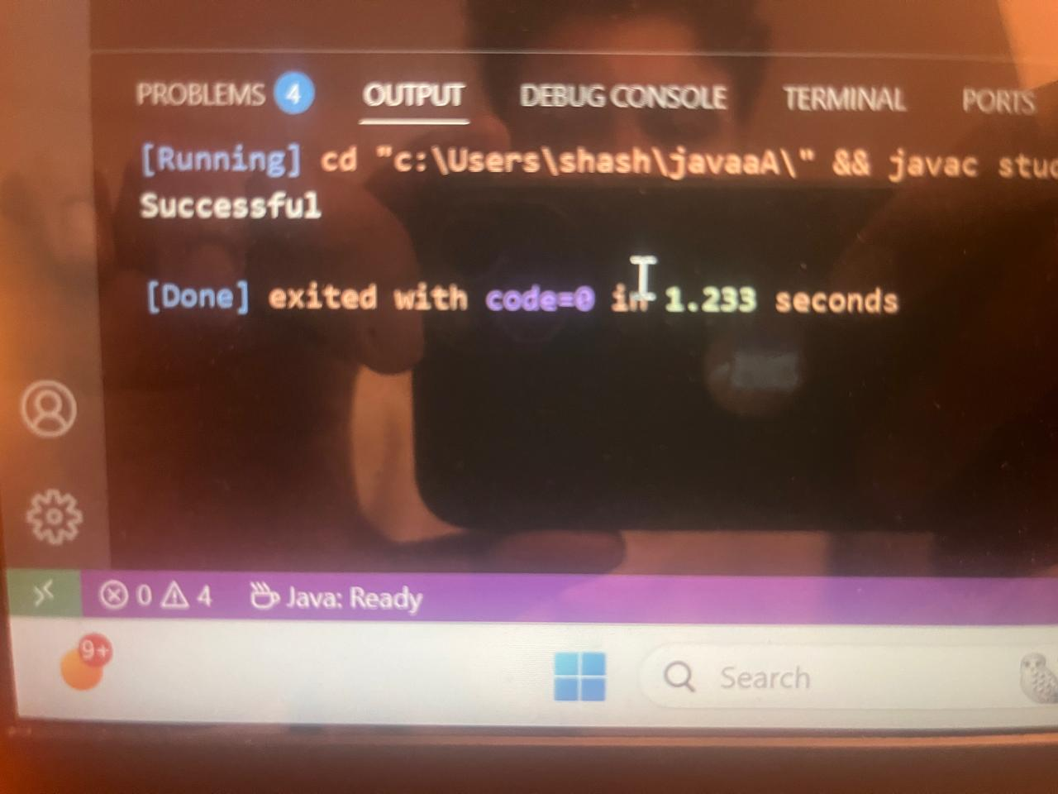

Qus 2nd lab 2nd
public class employee {
int id;
protected int age;
protected String name;

protected boolean isPermanent;

public static void main(String[] args) {
// tring to assign 35.5 age directly would cause an error

employee emp = new employee();
// correct way to written
emp.age = (int) 35.5;
System.out.println("sucessful");
}
}

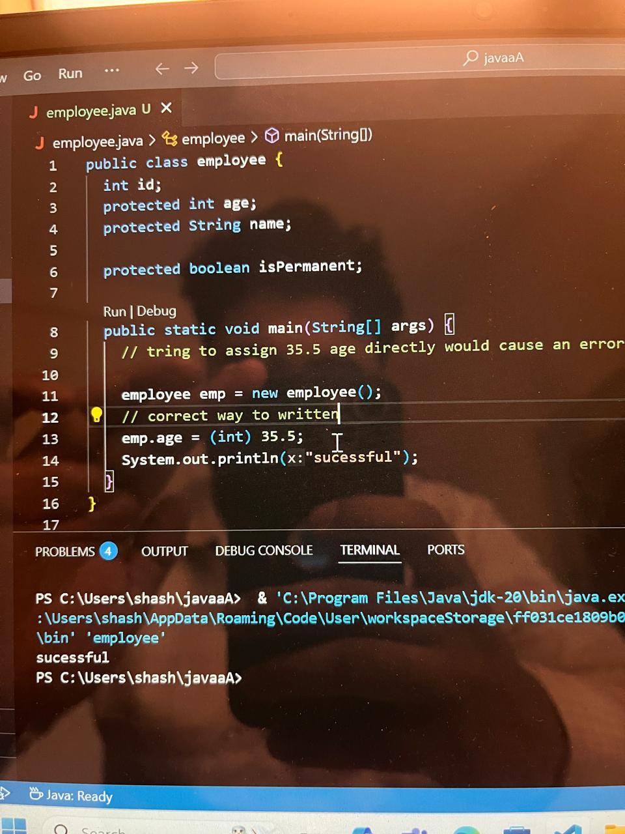

Qus 3rd
public class person {
int String;
int age;
int salary;

public static void main(String[] args) {
System.out.println("test successful");
}
}

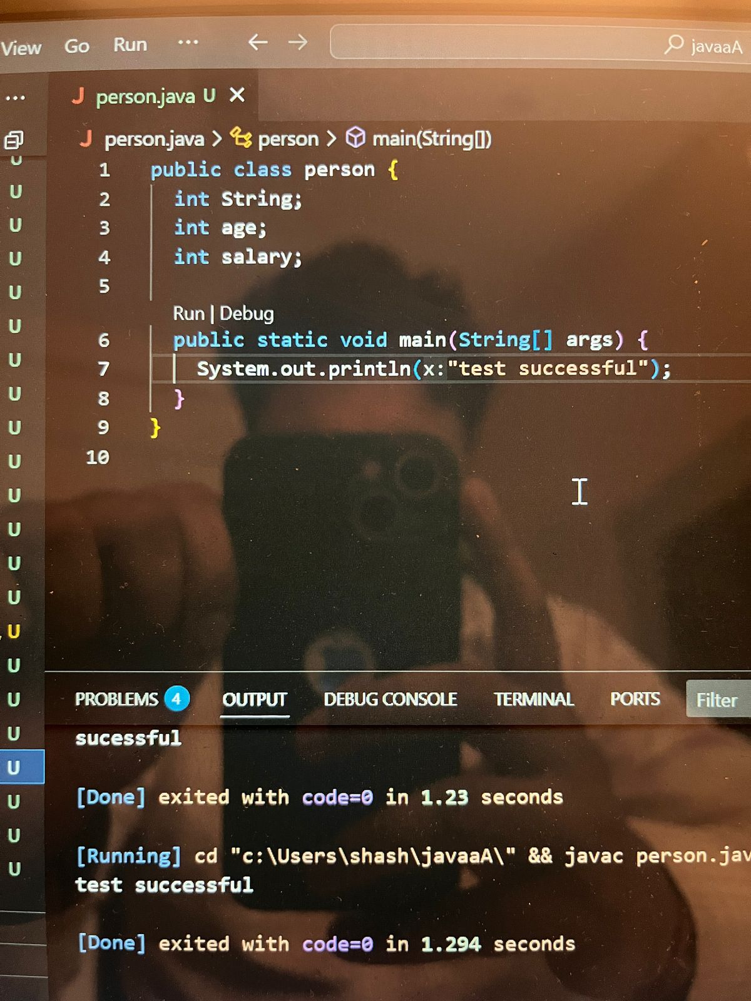
Qus 4th
public class reactangle {
double height;
double width;

enum color {
RED, GREEN, BLUE
}

color boxcolor;

public static void main(String[] args) {
System.out.println(color.BLUE);
}
}

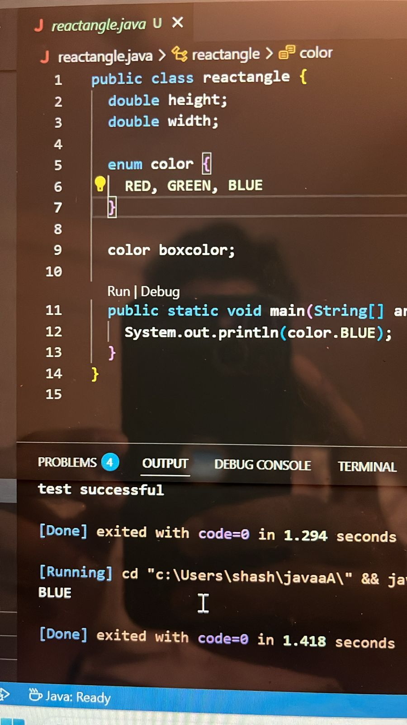

- Lab3 qus 1

import java.util.Scanner;

public class Car {
String make;
String model;
short year;
int price;

public Car(String make, String model, short year, int price) {
this.make = make;
this.model = model;
this.year = year;
this.price = price;
}

public void displayCarDetails() {
System.out.println("Make: " + make);
System.out.println("Model: " + model);
System.out.println("Year: " + year);
System.out.println("Price: $" + price);
System.out.println("--------------------");
}

public static void main(String[] args) {
Scanner scanner = new Scanner(System.in);
Car[] cars = new Car[5]; // Let's allow up to 5 cars for this example
int carCount = 0;

while (true) {
System.out.println("Enter 'add' to add a car, 'display' to show all cars, or 'exit' to quit:");
String action = scanner.nextLine().toLowerCase();

if (action.equals("add")) {
if (carCount < cars.length) {
System.out.print("Enter the make of the car: ");
String make = scanner.nextLine();

System.out.print("Enter the model of the car: ");
String model = scanner.nextLine();

System.out.print("Enter the year of the car: ");
short year = scanner.nextShort();
scanner.nextLine(); // Consume the newline character

System.out.print("Enter the price of the car: $");
int price = scanner.nextInt();
scanner.nextLine();

cars[carCount++] = new Car(make, model, year, price);
System.out.println("Car added successfully!");
} else {
System.out.println("You have reached the maximum number of cars.");
}
} else if (action.equals("display")) {
if (carCount > 0) {
System.out.println("\n--- Car Details ---");
for (int i = 0; i < carCount; i++) {
cars[i].displayCarDetails();
}
} else {
System.out.println("No cars have been added yet.");
}
} else if (action.equals("exit")) {
System.out.println("Exiting the program. Goodbye!");
break;
} else {
System.out.println("Invalid action. Please enter 'add', 'display', or 'exit'.");
}
System.out.println();
}
scanner.close();
}
}
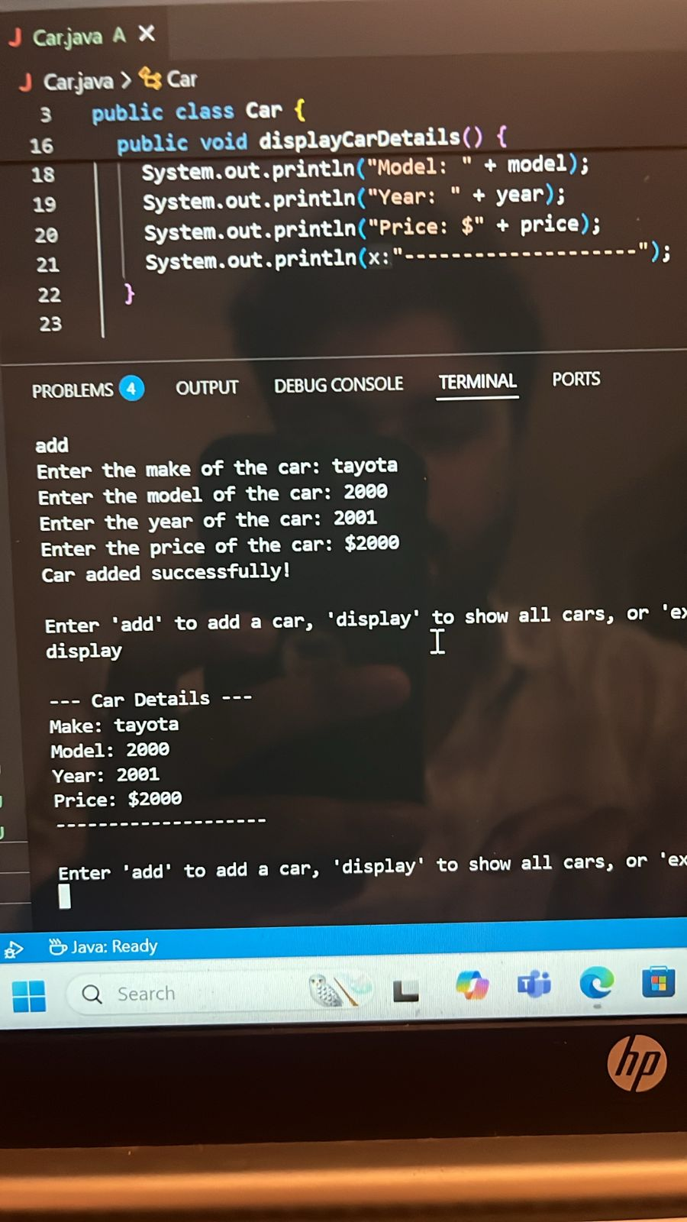

Qus 3rd lab 3rd assignment

public class Student1 implements java.io.Serializable {
private String name;
private int age;
private String department;

// Constructor that takes all three attributes
public Student1(String name, int age, String department) {
this.name = name;
this.age = age;
this.department = department;
}

// Getter method for name
public String getName() {
return name;
}

// Setter method for name
public void setName(String name) {
this.name = name;
}

// Getter method for age
public int getAge() {
return age;
}

// Setter method for age
public void setAge(int age) {
this.age = age;
}

// Getter method for department
public String getDepartment() {
return department;
}

// Setter method for department
public void setDepartment(String department) {
this.department = department;
}

// Optional: You can add a toString() method for easy printing of the object
@Override
public String toString() {
return "Student1{" +
"name='" + name + '\'' +
", age=" + age +
", department='" + department + '\'' +
'}';
}

public static void main(String[] args) {
// Example of creating and using the Student1 JavaBean
Student1 student = new Student1("Alice", 20, "Computer Science");
System.out.println("Student Details:");
System.out.println("Name: " + student.getName());
System.out.println("Age: " + student.getAge());
System.out.println("Department: " + student.getDepartment());

// Using the setter methods to update attributes
student.setAge(21);
student.setDepartment("Information Technology");
System.out.println("\nUpdated Student Details:");
System.out.println(student); // Using the toString() method
}
}
